**Project BeachTime**

**Summary**

BeachTime is an application that tracks consultants "on the beach", or between clients. Users will register for the beach, upload their résumé, and tag their identities with useful metadata. Account executives will be able to search for available consultants based upon the provided metadata.

**Motivation**

Sogeti consultants who are not actively billing a client are said to be "on the beach". Each consultant has a skill set, but those skill sets differ greatly among consultants. One consultant might develop on the Microsoft stack, while another may specialize in quality assurance. It is difficult to know, at a glance, what skill sets are currently available. BeachTime will consolidate this information, so that account executives can readily know what is available for placement at a new client.

**Functional Details**

BeachTime will provide the following functionality:

**User Registry, Login, and Maintenance**

* Allow users to register to BeachTime.
  + Login ID must be unique.
  + Password must not be stored in plain text.
  + First Name
  + Last Name
  + E-mail
  + User Type (Consultant or Account Executive)
  + phone
* User Login.
* User authentication persists across all web pages.
* Without authentication, all web pages redirect to User Login.
* User Logout.
* User Maintenance
  + Users may only maintain their own details.
  + Current beach status
  + List of keywords
    - Add new keywords
    - Remove keyword association
  + Phone number
  + Upload résumé
  + User Type Change

**Account Executive Dashboard**

* List all consultants currently on the beach.
* List all available metadata tags.
* Filter by tags.
* Filter by search.
* Link to download a specific consultant's résumé.
* Link to e-mail a specific consultant.
* Link to e-mail all consultants on the beach.

***Further functionality pursuable as time permits.***

**Required Skills**

Developers on this project will require the following skill set:

* Any web development technology (ASP.NET and C# preferred but not required)
* T-SQL (Microsoft SQL Server preferred)

**Required Agreements**

No non-disclosure agreement to be signed. If the project can be converted to a commercial application, it is equally owned by proposers, Sogeti, and the students working on the project.

Database Initial Study

Enterprise level database (MS SQL Server)

Interaction with internal application and possibly web services

**Roles**

DBA: access to maintain/optimize

Front-end dev: application-tier accesses DB securely (password hashing)

End-users: 2 types (consultants/account executives) with no access to DB

**Compliance**

Important to achieve data security/ database compliance this will include:

• appropriate governance

• secure platform

• strict identity/access control

• DB encryption

• Auditing

**Functions** (create, read, update and delete)

1. user registry/ create login-id (unique)

2. user login

3. user authentication (*levels)

4. user logout

5. read login-id

6. CRU password

7. CRU first name

8. CRU last name

9. CRU email

10. CRU user-type

11. CRUD keyword

12. CRUD keyword associations

13. CRUD phone number

14. CRUD résumé

15. CRU beach status

16. list all active consultants on beach (view)

17. list all available metadata tags (view)

18. 18. filter by tags (select query)

19. filter by search (select query)

20. acct execs can R consultant data (select query)

21. access rights

**Assumptions/Rules/Limitations**

• all end-users can only create/modify their own information

• all users can read their own info

• all account execs can read all pertinent consultant data

• DB is encrypted

• DB has back-ups and transaction logs (stored procedures/triggers)

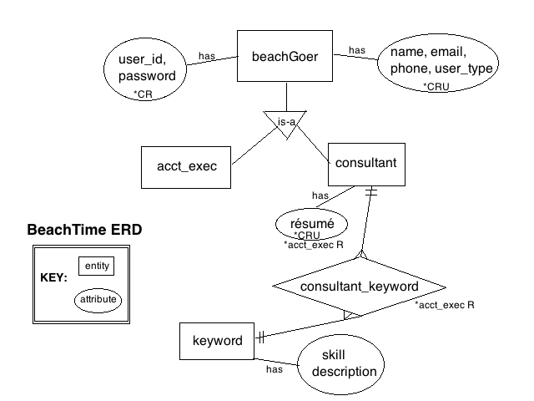

Is BeachTime totally standalone?

Does it or should it or will it interface with any other corporate app?

Does BeachTime store data that exists somewhere else

what is a skill??

Does a skill have a proficiency level?

If Consultant is currently available (not engaged) consultant skills should be an available to skill inventory to beach time.

If consultant is currently engaged (not available) consultant skills should **NOT** be available beach time inventory.

How do I get on?

How do I get off

Example of print metadata?

So next, we need to create a Technical Specification document.

What is primarily required at this point, to move forward, are mock-ups of **all** the UI forms or pages which should include **all of the desired functions.** *Also important to include **a list of assumptions**.

So these mockups should contain **all the functionality that the whole project requires** and so there should be quite a few pages. These can be simple paint images. **I attached a basic example**. It doesn't have to be beautiful; can be simple boxes and arrows. James would like us to get this to him sooner than later so that he can provide his feedback.

John M.- you probably agrees this falls primarily under your domain, so the team defers to you in this.